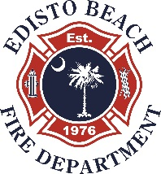
VOLUNTEERS
EBVFD Quarterly Business Meeting
November 3, 2016
6:30 PM
Welcome and introduction of guests
Thanks to cooks George and Jackie Bothers
Approval of August meeting minutes
Approved, no corrections
Financial Report
Distributed and accepted as presented
Unfinished Business
Training- Deferred
Hurricane Mathew
List of items needing replacement from use or damage distributed.
Motion by Mike Kelly, second by Bobby Youmans to purchase replacement items
with available volunteer funds. Motion accepted unanimously by membership.
Unfinished Business
EVDT Training- Proposal to provide focused training program monthly with quarterly business meetings presented by Cameron. Approved by members as presented.
New Business
Christmas Party. Membership approved. Information forthcoming.
Chief’s Report
Review of events and services provided by the FD during the hurricane provided by the Chief. He acknowledged the assistance of MANY individuals and multiple community groups/organizations to meet the needs of the community. The thanked everyone who participated and assisted with this massive effort. He noted the tremendous response of community members and volunteers from surrounding areas. He encouraged members to continue support of neighbors and all community residents/owners. The damage is extensive and will require much time and effort for clean-up and repair. He expressed much praise for the community’s response and willingness to help others in the community. We have much to learn from this experience. Recommendations anticipated to follow.

Initial list of items used and needing replacement provided. Membership supported assisting with cost of replacement with no dessent.

Next quarterly business meeting January 5, 2017

Adjournment

